Instructions
Please send your completed applications to ana.dragutescu@iclei.org
Please also email us if you have any further questions

Section 1 - Applicant city details
Please provide the following general information about your organization
Official name
Name in English
Region
Country
Population
Land area
Website

Section 2 - Nominated contacts
A: Official level contact
Please designate a person in your organization to serve as the primary contact for the Follower City Group
Name
Title/function
Department
Address
Postcode
Email
Telephone

Section 3 - Involvement in Follower Cities Group
Outline the basis of your interest in being a Follower City of the CIVITAS SUMP-PLUS project. (200 words max)
Co-Creation Laboratories (CLs) test cases
Please identify and prioritise two CLs you would like to follow and learn more about.
A list and description can be found in Annex 1.

Section 4 - Requirements and signature
We hereby apply for membership of the CIVITAS SUMP-PLUS Follower Cities' Group and, if selected, commit to delivering the following requirements of the project:
- Test the replicability of the selected Co-Created Laboratories and validate the approaches and solutions
- Provide feedback and input to the Project Partners regarding their Implementation Reports
- Attending at least one CIVITAS SUMP-PLUS study visits, virtual or in person
- Be a mentor in the Train-the-trainer training activities in the last year of the project and provide a short document on your experience in this project, in needed.

Official stamp:

Name and position of city representative (departmental head or above):

Date: ________________________

Signature of representative:

Annex: Description of the CIVITAS SUMP-PLUS Co-Creation Laboratories (CLs)

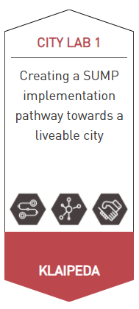
City Lab 1 (more information here)
Objectives:
- Develop context-specific mobility transformation pathways
- Forge cross-sectoral links between transport, public services, and commerce
- Create new forms of public-private partnerships and business models

Scenario:
Following its adoption of an ambitious SUMP in 2018, Klaipeda is planning its SUMP implementation pathway. This will accelerate its transformation from car-dominated streetscapes to a liveable city with inclusive and green mobility.
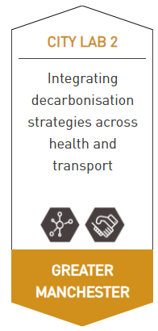
City Lab 2 (more information here)
Objectives:
- Forge cross-sectoral links between transport, public services, and commerce
- Create new forms of public-private partnerships and business models

Scenario:
In order to maximise the efficiency of investment in Greater Manchester’s health and transport sectors, cross-sectoral links need to be deepened. The approach for doing so will draw on experience gathered during COVID-19 in relation to new ways of working.
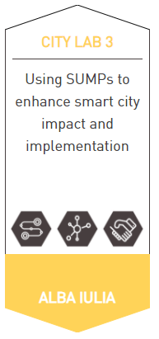
City Lab 3 (more information here)
Objectives:
- Develop context-specific mobility transformation pathways
- Forge cross-sectoral links between transport, public services, and commerce
- Create new forms of public-private partnerships and business models

Scenario:
The medium-sized Transylvanian city of Alba Iulia is Romania’s smart city pioneer. Within SUMP-PLUS, it will seek to upscale mobility-related technology innovations as part of its SUMP implementation pathway. This will also involve transformational public transport projects.

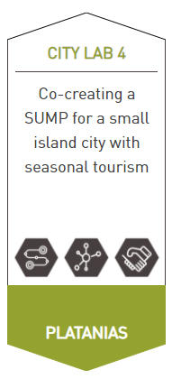
City Lab 4 (more information here)
Objectives:
- Develop context-specific mobility transformation pathways
- Forge cross-sectoral links between transport, public services, and commerce
- Create new forms of public-private partnerships and business models

Scenario:
Testing a tailored approach developed for smaller urban areas, Platanias is developing a SUMP and supporting implementation pathway for its cross-municipal functional area. This will seek to address mobility challenges specific to touristic island locations, including high seasonal fluctuations in mobility demand and creating links between the hinterland and urban areas.
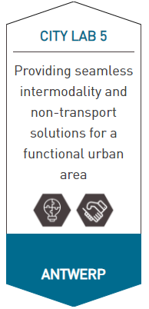
City Lab 5 (more information here)
Objectives:
- Implement and monitor cutting-edge mobility solutions
- Create new forms of public-private partnerships and business models

Scenario:
Antwerp will intensify its cross-boundary partnerships with surrounding municipalities in order to deliver attractive, convenient and safe intermodal travel options running from the commuter belt into the city. The objective is to bring transport services up to the quality of its award-winning intermodal journey planner.
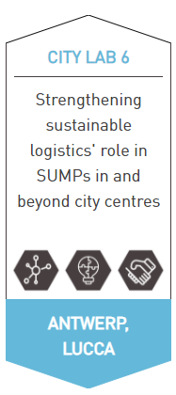
City Lab 6 (more information here)
Objectives:
- Forge cross-sectoral links between transport, public services, and commerce
- Implement and monitor cutting-edge mobility solutions
- Create new forms of public-private partnerships and business models

Scenario:
Lucca will seek to strengthen the regional logistics component of its SUMP, with both Antwerp and Lucca looking to develop partnership models and incentives schemes for working with the logistics sector. These will help deliver new and expanded urban freight solutions within and around both city centres.

